1. In the last module, we started three containers (MongoDB, Backend App, and Front-End App).   
   A screenshot of a computer

   Description automatically generated
2. It is very cumbersome to bring this setup up as a lot of things are involved like.
   1. A black background with red text

      Description automatically generated
   2. A computer screen with red text

      Description automatically generated
   3. 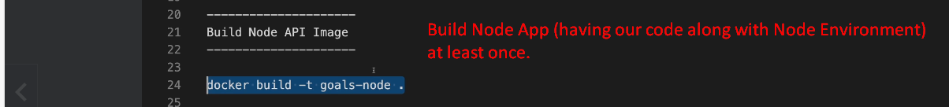
   4. A screen shot of a computer

      Description automatically generated
   5. A black background with red text

      Description automatically generated
   6. Now, when we want to stop everything including network deletion, we have to release many commands.
   7. This is basic app where we have three containers working together but in the real-world they are many.
3. Docker eco-system ships another tool 🡪 Docker-Compose which makes managing multi-containers setup easier.   
   We can bring the setup up with a single command and one command to bring that down along with container deletion, network deletion etc.  
   A close-up of a sign

   Description automatically generated
4. A close-up of a website

   Description automatically generated